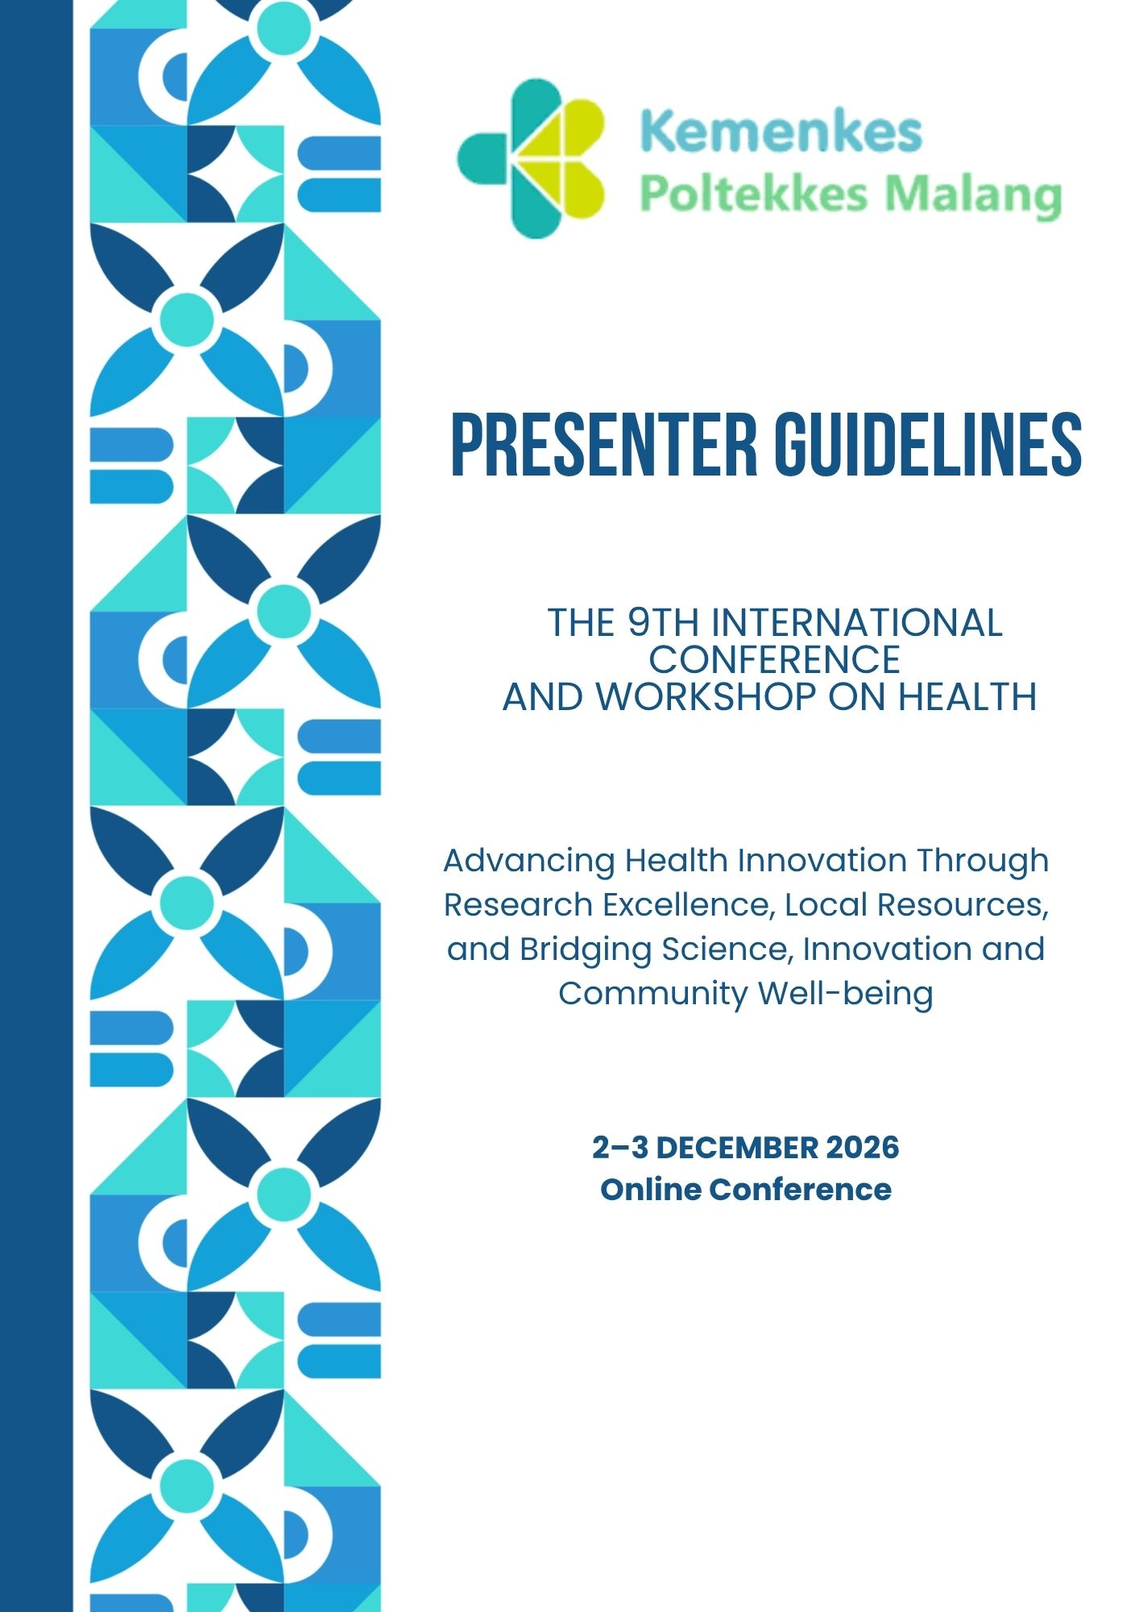

THE 9TH INTERNATIONAL CONFERENCE AND WORKSHOP ON HEALTH 2026
ORAL & POSTER PRESENTER GUIDELINES
Advancing Health Innovation through Research Excellence, Local Resources, and Sustainable Healthcare: Bridging Science, Innovation, and Community Well-being

CONFERENCE FORMAT
Online conference | 2 – 3 December 2026
Oral and poster presentation session: Thursday, 3 December 2026 (WIB)

LANGUAGE
All oral and poster presentations must be delivered in English.

1. General Information
These guidelines apply to presenters assigned to the oral or poster presentation sessions of ICWH 2026. Presenters should prepare materials in accordance with the official ICWH 2026 templates, join the online meeting on time, and follow instructions from the session moderator and organizing committee.
The conference welcomes research and innovation within these areas:
- Nutrition
- Nursing
- Midwifery
- Pharmaceutical and Food Analysis and Blood Bank Technology
- Health Information Management & Health Insurance
- Occupational Health & Health Promotion

Presenters are responsible for ensuring that their work is accurately represented and that participant, patient, or institutional information is handled in accordance with applicable ethical and confidentiality requirements.

2. Important Dates and Conference Timeline
Date / Time (WIB) | Activity | What presenters should do
26 October–11 November 2026 | Registration, payment, and abstract submission | Complete the applicable registration and abstract-submission process.
26 October–25 November 2026 | Full paper submission | Submit a full paper if required for your participation or publication pathway.
2 December 2026 | Conference Day 1 | Check the official website for the conference program and announcements.
3 December 2026 | Oral and poster presentation day | Join the main Zoom room for attendance and briefing, then follow instructions to enter the assigned breakout room.

SCHEDULE REMINDER
The timeline above reflects the current event rundown. Individual presentation slots, assigned breakout rooms, Zoom access details, and any changes will be communicated through official ICWH 2026 channels.

3. Oral Presentation Guidelines
A. Presentation file and template
- Use the official ICWH 2026 Oral Presentation Template available from the conference website: icwh.poltekkes-malang.ac.id
- Prepare the presentation in English.
- Keep the slide deck in the format supported by the official template. If the committee provides a specific submission format or asks for an additional PDF copy, follow that announcement.
- Do not alter the template’s required structure unless instructed by the organizing committee.
- Make sure the final file opens correctly on your device and keep a backup copy available.
B. Recommended content and slide sequence
Template section | Recommended content
Title / Research Team | Present the full title of the study, name of the presenting author, co-authors, and institutional affiliations. Clearly indicate or highlight the presenting author.
Background (1 slide) | Briefly introduce the research problem and its significance. Include relevant data or evidence to establish the importance of the topic. Identify the research gap and explain why the study is necessary. Focus on the most relevant information rather than providing an extensive literature review.
Objectives (1 slide) | Clearly state the main objective of the study. Include specific objectives, research questions, or hypotheses when applicable. Ensure that the objectives are consistent with the research methods and reported findings.
Methods (1 slide) | Provide a concise description of the research methodology, including study design, setting and location, study population and sample, sampling technique, inclusion and exclusion criteria (if applicable), data collection procedures, research instruments, outcome variables, and data analysis. Briefly mention ethical approval and informed consent where applicable.
Results and Discussion (3 slide) | Present the main findings in a logical sequence using clear and readable tables, graphs, charts, or figures. Highlight the most important results relevant to the research objectives. Include key statistical findings where applicable. Interpret the findings, compare them with relevant previous studies or scientific evidence, and explain their implications. Focus on the meaning and significance of the results rather than simply repeating the data.
Conclusion (1 slide) | Summarize the main findings and provide a clear answer to the research objectives or questions. Highlight the key contribution or practical implications of the study. Conclusions must be supported by the results presented.
References (1 slide) | List the key references cited in the presentation. Prioritize relevant and credible scientific sources, particularly recent peer-reviewed publications. Use a consistent referencing style throughout the slide.
The supplied ICWH 2026 oral template is organized around Title/Research Team, Background, Objectives, Methods, Results and Discussion, Conclusion, and References, with space for multiple results/discussion slides and an additional slide. Please follow the actual slide order and labels in the downloaded template.

C. Slide design and delivery
- Keep each slide focused on one main idea and avoid dense paragraphs.
- Use readable font sizes, high contrast, clear headings, and consistent formatting.
- Use tables, charts, and images only when they help explain the findings; label figures and tables clearly and include units where relevant.
- Use visuals that remain legible when shared on a screen. Avoid unnecessary animations or media that may cause technical problems.
- Practice in advance and aim to finish within the allotted presentation time. Do not read the manuscript or slides word for word; explain the key findings in your own words.
- Check spelling, author names, affiliations, numerical values, and references before presenting.
D. Timing and questions
- Oral Presentation Slot
Total duration: 15 minutes, consisting of 10 minutes for the presentation, followed by 5 minutes for the question-and-answer (Q&A) session. The time allocation may be adjusted depending on the number of participants.
- Listen to each question before responding. Answer clearly, concisely, and respectfully.
- If a question falls outside the scope of the study or you do not know the answer, acknowledge this honestly and explain any relevant limitation.
- Remain in the assigned breakout room until the moderator or room PIC gives further instructions.

Before your oral presentation
• Use the official ICWH 2026 oral presentation template and present in English.
• Rehearse to finish within the 10-minute presentation limit.
• Test your internet connection, microphone, and screen sharing before the session.

4. Poster Presentation Guidelines
A. Poster format and template
  - Official Poster Template: Participants may use the official ICWH 2026 poster template as a reference. The template can be downloaded from the conference website.
  - Poster Orientation: The provided template uses a portrait orientation. Participants must follow the dimensions and canvas proportions specified in the official template. Changing the orientation to landscape is not permitted.
  - Poster Language: All posters must be prepared in English.
  - Content Readability: All text, images, graphs, tables, and references must be clearly legible when the poster is displayed on a computer screen.
  - Structure and Layout: Posters must be concise, informative, easy to understand, and well-organized. Use appropriate titles and subtitles for each section and arrange the information systematically to ensure readability.
  - Design and Visual Appearance: Use a combination of text and background colors with sufficient contrast to ensure readability. Avoid excessively long paragraphs, overcrowded information, and excessive decorative elements.
  - Final File Inspection: Before submission, participants must carefully review the exported poster file to ensure that there are no issues, such as:
- Missing or altered fonts.
- Clipped content.
- Low-resolution images.
- Text or visual elements extending beyond the poster canvas boundaries.
Note: Ensure that all images, tables, graphs, and text remain sharp and clear, without pixelation or distortion. All information must be clearly readable in the submitted poster.
B. Poster content
Section in the ICWH template | What to include
Title / Authors | Research title, author names, presenting author, and institutional affiliations.
Background | Problem statement, brief supporting evidence, and research gap or rationale.
Objectives | Clear statement of the study purpose.
Methods | Study design, participants/sample, procedures, measures, analysis, and ethics information where applicable.
Results | Main findings supported by readable charts, figures, or concise tables.
Discussion | Interpretation of the findings and comparison with relevant evidence.
Conclusion | Concise take-home message aligned with the objectives and results.
Implications | Practical, clinical, educational, policy, or community implications supported by the findings.
References | Key sources cited on the poster, presented consistently.

The supplied ICWH poster template includes the headings BACKGROUND, OBJECTIVES, METHODS, RESULTS, DISCUSSION, CONCLUSION, IMPLICATIONS, REFERENCES, and AUTHORS. Please retain the template’s section labels.

C. Poster presentation
- Poster presentations will be conducted online. Participants are required to submit their posters in accordance with the guidelines provided by the organizing committee.
- The organizing committee will compile all submitted posters into a video presentation, which will be screened during a designated session via Zoom Meeting. Individual live presentations by poster authors are not required.
- All posters will be evaluated independently by a panel of judges appointed by the organizing committee. The evaluation process will take place outside the main conference schedule. The winners of the poster presentation category will be announced during the closing session of the conference.
- Participants presenting posters are encouraged to attend the entire conference program, including the opening, scientific sessions, and closing ceremony.

5. Online Presentation Requirements
- Join the main Zoom room during the 08.00–08.15 WIB attendance window on 3 December 2026, unless official instructions specify otherwise.
- Use a laptop or desktop if possible, with a stable internet connection, working microphone, and camera. Headphones are recommended to reduce echo.
- Test your microphone, camera, and screen-sharing function before the session.
- Use a professional Zoom display name. Follow the naming format if one is announced by the committee; the exact format has not been specified in the materials available for this guideline.
- Keep your microphone muted when you are not speaking. Follow the moderator’s instructions regarding camera use.
- Do not leave the assigned room without notifying the moderator or room PIC if you encounter technical issues.
- If screen sharing or connectivity fails, notify the room PIC/organizing committee using the official communication channel and follow their instructions.
- Do not record or distribute other presenters’ materials or meeting content without permission.

6. Important Dates and More Information
Official website: https://icwh.poltekkes-malang.ac.id
Please visit the official website for the latest conference announcements, registration information, presenter guidelines, oral/poster templates, paper templates, and virtual background.
Contact person | WhatsApp
Eiska | +62 812-2816-8735
Riska | +62 817-0505-995
Budi | +62 856-3551-209

PLEASE CONFIRM THROUGH OFFICIAL CHANNELS
The submission platform and deadline for oral slides/poster files, exact Zoom display-name format, individual presentation schedule, and any additional file requirements should be checked in official ICWH 2026 announcements. These details are not specified in the materials used to prepare this document.

